Fiori Tile F1606

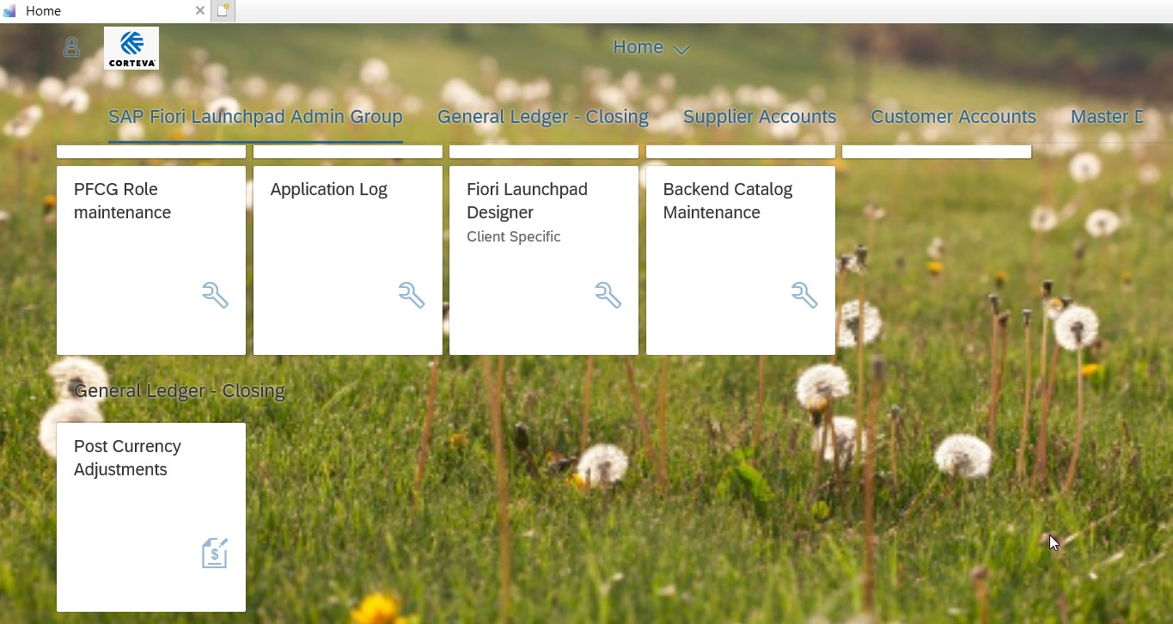

Enter in dates, company code, Transaction currency, ledger group, and chose currency as Z1

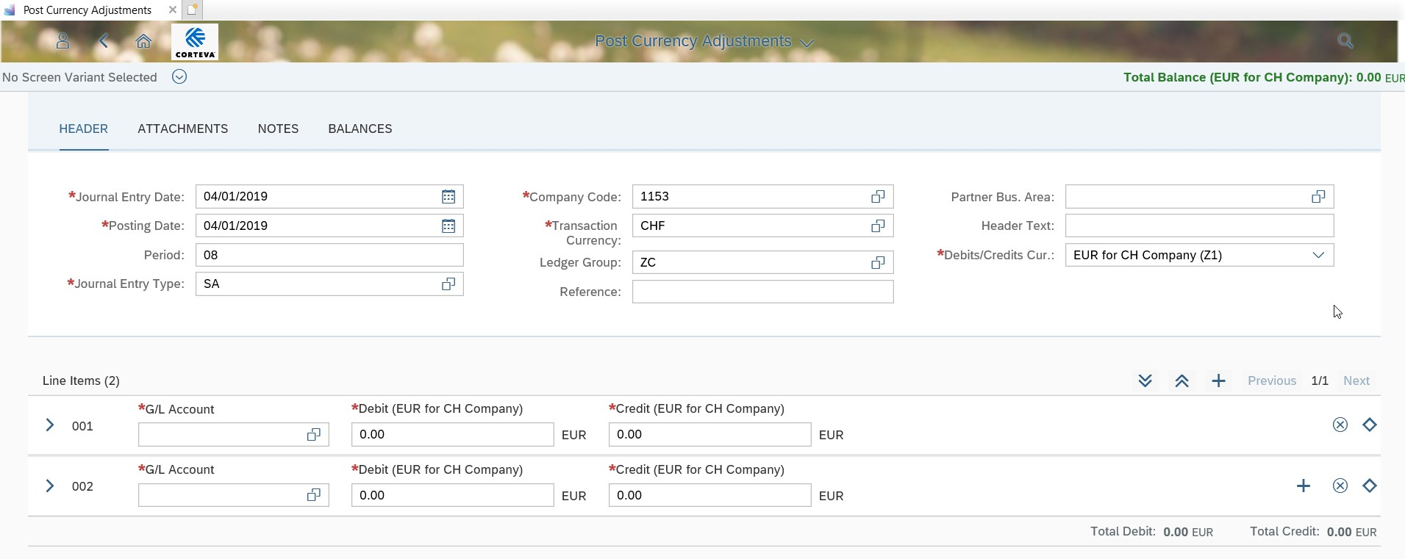

Entered GL accounts and debits and credits, then hit enter

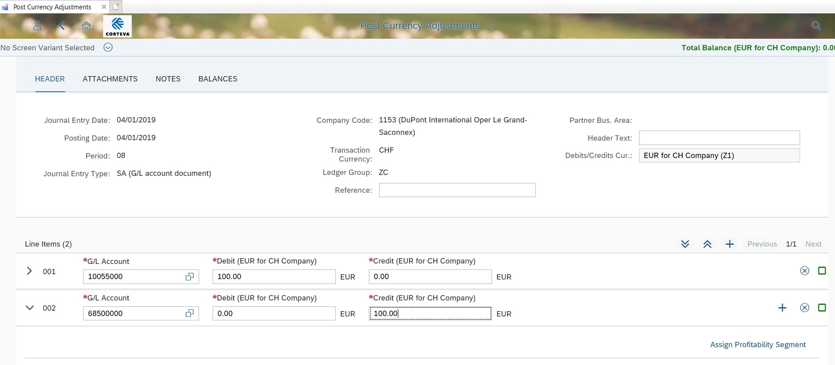

Entered cost center then hit enter.

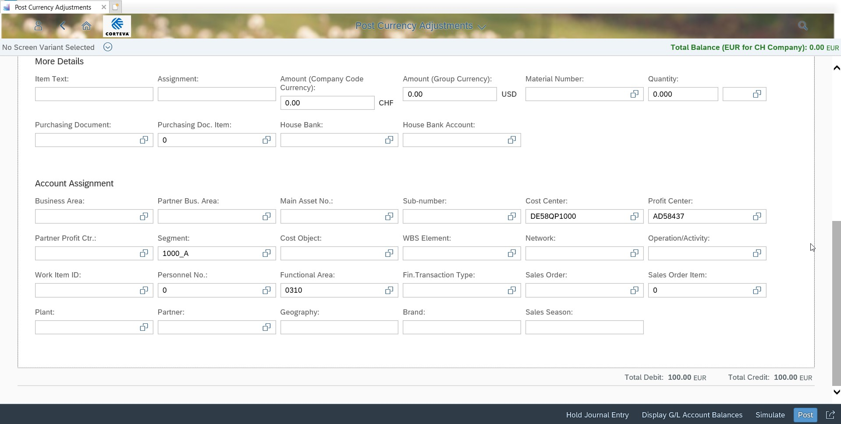

Hit simulate, then post:

